A Web -Based Application that Connects Charity Organisations to Donors in Kenya:

By:
Opondo Tobias Ochieng
Student ID:134980

An Information System Project 1 documentation submitted to the School of Computing and Engineering Sciences in partial fulfilment of the requirements for the award of the bachelor’s degree in business information technology of Strathmore University

School of Computing and Engineering Sciences
Strathmore University
Nairobi, Kenya.

April 2026

Declaration
I declare that this work has not been previously submitted and approved for the award of a Bachelor’s degree by this or any other University. To the best of my knowledge and belief, the proposal contains no material previously published or written by another person except where due reference is made in the proposal itself.

Student’s signature:

………………………………….………….. [Signature]

………………………………….………….. [Date]

Approval
The Information System Project 1 document of Opondo Tobias Ochieng was reviewed and approved (for examination) by:

Supervisor’s signature:

………………………………….………….. [Signature]

………………………………….………….. [Date]

Abstract
This study focuses on developing a web-based application that connects donors with charitable organizations to support a continuous and progressive journey toward philanthropy. As digital platforms become more widely used, charitable organizations are adopting technology to improve fundraising and donor engagement; however, many donors still lack effective tools to monitor and evaluate projects before committing funds. The major challenge addressed in this study is the difficulty organizations face in raising consistent funding and the absence of systems that provide clear, personalized project information to support informed donor decisions. Existing fundraising platforms mainly support general donations but lack individualized portfolio tracking and analysis features, creating a gap that prevents donors from easily assessing project performance and selecting projects aligned with their interests and funding capacity. To address this gap, the proposed system is developed using the Iterative Waterfall Model and guided by the Structured Systems Analysis and Design Approach (SSADA) for systematic planning and implementation. The solution is a web-based platform that incorporates portfolio-based reporting and project analysis tools, supported by modern front-end, back-end, and database technologies, with the ultimate goal of improving transparency, strengthening donor–charity relationships, and increasing funding for charitable initiatives.

Keywords: Connective, web based application, donors and charitable organization, financial challenges, object oriented design approach, conceptual framework and iterative waterfall model.

Table of Contents
Declaration 2
Abstract 3
List of Figures 6
Acknowledgements 7
Chapter 1: Introduction 8
Background 8
Problem Statement 9
Aim 10
Specific Objectives 10
Research Questions 11
Justification 11
Scope and Limitations 12
Chapter 2: Literature Review 13
Introduction 13
2.2 Challenges Faced by Donor Funding. 14
2.2.1 Financial Challenges Faced by Charitable Organizations 14
2.2.2 Inconsistent and Unpredictable Funding Sources 15
2.2.2 Lack of Transparency and Accountability Systems 15
2.2.3 High Operational and Fundraising Costs 15
2.3 Existing Methods Used by Charitable Organizations to Engage Donors 16
2.3.1 Traditional Fundraising Methods 16
2.3.2 Social Media and Digital Communication Platforms 16
2.3.3 Crowdfunding Platforms 16
2.4. Review of Existing Systems. 17
2.4.1. DonorBox 17
2.4.2. Fundly 18
Gaps in existing system 20
Conceptual Framework 20
Chapter 3: Methodology 22
3.1 Introduction 22
3.2 Agile Iterative Prototyping Methodology 22
SDM Process Diagram 23
3.2.1 Requirement Gathering 24
3.2.2 Planning and Analysis 24
3.2.3 System Design (OOAD Phase) 24
3.2.4 Implementation, Testing and Refinement 24
3.3 System Implementation Tools 25
3.3.1 Front End 25
3.3.2 Back End 25
3.3.3 Database 26
3.3.4 Testing 26
3.4 Deliverables 27
3.4.1 User Authentication Module 27
3.4.2 Donor Management Module 27
3.4.3 Donation Processing Module 27
3.4.4 Reporting and Analytics Module 27
Chapter 4: Analysis and Design 28
4.1 Introduction 28
4.2 Requirements Analysis 28
4.2.1 Functional Requirements 28
4.2.2 Non-Functional Requirements 29
4.4 Diagrams 30
4.4.1 Use Case 30
4.4.1.1 Use CaseNarrative 30
4.4.1.2 Use CaseNarrative 31
4.4.1.3 Use CaseNarrative 32
4.4.2 Sequence Diagram 33
4.4.5 Class Diagram 39
Chapter 5: Implementation and Testing 40
5.1 Introduction 40
5.2 Description of the Implementation Environment 40
5.2.1 Hardware Specifications 40
5.2.2 Software Specifications 41
5.2.2.1. Operating System 41
5.2.2.2 Web Server 42
5.2.2.3 Database Management System 42
5.2.2.4 Browser 42
5.3 Description of Testing 42
5.3.1 Evaluations and Metrics Used 43
5.3.2 Testing Paradigm (Functional Testing) 43
Chapter 6. Conclusion and Recommendation 49
6.1 Conclusion 49
References 51

List of Figures
Figure 1:Charity Organizations
Figure 2.1: DonorBox Payment Form
Figure 2.2: Fundly Webpage
Figure 2.3: Conceptual Framework
Figure 3.1: System Development Lifecycle
Figure 4:Sequence Diagram
Figure 5: Database schema
Figure 6: Class Diagram

Acknowledgements

I would like to express my sincere gratitude to my family who contributed to the development of this proposal. Their valuable insights, guidance, and support have been instrumental in shaping this document.

I would like to extend my heartfelt appreciation to Mrs. Zainabu Muti, my supervisor for her expertise and valuable contributions. Her input and feedback have greatly enhanced the quality and potential of this proposal.

Introduction

Background
Charity organizations can be traced back to ancient times when individuals and communities recognized the importance of helping those in need. While the concept of charity has evolved over the centuries, the underlying principle of aiding the less fortunate remains the same. (Taggart, 2021) Christianity played a significant role in the development of organized charity. Early Christians emphasized the importance of caring for the poor and established charitable institutions, such as hospitals, orphanages, and hospices. During Lent, a season of reflection, fasting, and spiritual renewal, Matthew 6:3-4 reminds us of the profound importance of genuine charity: "But when you give to the needy, do not let your left hand know what your right hand is doing, so that your giving may be in secret. Then your father, who sees what is done in secret, will reward you." Islamic traditions, through the practice of Zakat (almsgiving), emphasized the obligation to assist the poor and disadvantaged. (Attridge, 2020)
In recent decades, there has been an increasing emphasis on accountability, transparency, and professionalism in the charity sector (Baranowski, 2019). Organizations like Charity Navigator have emerged to provide assessments and ratings of non-profit organizations. The rise of online platforms and crowdfunding has facilitated new forms of charitable giving, enabling individuals to directly support causes and organizations of their choice. (Chiesa, 2023)
A major problem towards addressing charity organizations is donor funding (Ashley, 2019). The gap is so huge that it tends to stall the projects to be done for some periods. Addressing these gaps is significant because it can inform the development of more effective and culturally sensitive web-based applications that can improve donor funding to Kenyan charity organizations. By exploring the effectiveness of these applications, we can provide evidence-based recommendations for charity organizations, policymakers, and developers to support the use of web-based applications for improving donor funding.

Figure 1.1 Charity Organisation

Organisation | Type | Focus Area | HQ/Base | Est
GiveDirectlyKenya | International NGO | Poverty Relief | Nairobi | 2011
World Vision Kenya | International NGO | Child Welfare | Nairobi | 1974
Compassion International | International NGO | Child Welfare | Nairobi | 1952
Amref Health Africa | Pan-African NGO | Health | Nairobi | 1957
Table 1.1 Examples of NGOs in Kenya

Problem Statement
Despite the critical role played by donor funding in supporting charitable organizations, there are several challenges that hinder their ability to effectively secure and utilize these resources. These challenges include limited funding availability, inconsistent and unpredictable funding, donor fatigue and shifting priorities, administrative expenses and lack of transparency and accountability. (Friedenthal, 2018)
Charitable organizations often face a scarcity of donor funding, as there is fierce competition among various organizations seeking financial support. This limited availability of funds hampers their ability to address pressing social issues and provide necessary services to vulnerable populations. Secondly, donor funding to charitable organizations can be inconsistent and unpredictable (Roddel, 2022), making it difficult for organizations to plan and implement sustainable programs. Fluctuating funding levels hinder the ability to maintain and expand services, leaving organizations vulnerable to sudden budget shortfalls and operational disruptions (Duong, 2020). Donor fatigue can occur when potential donors become overwhelmed by the sheer number of charitable appeals, leading to a decrease in overall funding (Kihlstedt, 2022). Additionally, charitable organizations often face significant administrative burdens associated with securing donor funding. The administrative overhead can divert valuable time and resources away from the core mission of the organization (Koehler, 2019).
Finally, donors may be hesitant to contribute funds to charitable organizations due to concerns regarding transparency and accountability. Without clear and reliable mechanisms for monitoring and evaluating the impact of donor funding, potential donors may hesitate to contribute, leading to missed opportunities for organizations to secure vital resources. (Barlett, 2016)

Aim
To develop a system that connects charity organizations to donors, hence facilitating donor funding.

Specific Objectives
- To analyse the financial challenges charitable organisations face while raising their funds.
- To assess existing methods that charitable organizations use to engage with donors.
- To design the proposed solution and system
- To test the proposed solution.

Research Questions
- How can a web-based system improve communication between donors and charitable organizations?
- What are the financial challenges of Kenyan charitable organizations?
- What are the existing solutions for charity organizations in Kenya for donor funding?
- How will the developed system be tested?

Justification
This study is important because charitable organizations rely heavily on donations to support their operations and community development projects such as education, healthcare, and poverty reduction initiatives. However, many organizations face challenges in maintaining consistent funding due to limited access to reliable digital tools that support effective communication with donors. The development of a web-based donor–charity connection system can improve transparency, accountability, and accessibility by providing donors with clear and organized information about projects. Additionally, the increasing use of digital platforms in everyday life makes it necessary for charitable organizations to adopt modern systems that allow them to reach more donors and reduce reliance on slow and error-prone manual processes.
The proposed system will benefit donors by providing personalized portfolio tracking tools that allow them to monitor their contributions and evaluate project progress, helping them make informed funding decisions. Charitable organizations will benefit from improved project visibility, better communication with donors, and automated reporting features that reduce administrative workload. Furthermore, this study contributes to the adoption of technology in nonprofit operations and provides useful knowledge for researchers and developers interested in digital fundraising systems. Overall, the system is expected to improve fundraising efficiency, strengthen donor relationships, and support the successful implementation of charitable projects that positively impact communities.

Scope and Limitations
The proposed system seeks to affect those who are engaging in philanthropic and community development projects, including donors who are interested in aiding these organizations. A SharePoint by donors who include angel investors and well-wishers gets to interact and connect with the charity organizations available.

This study focuses on verifying the authenticity and reliability of information that charity organizations provide, which can be challenging. Implementing mechanisms to validate data and ensure transparency in the application's processes is necessary to build trust among users.
This study does not cover the legal and regulatory considerations in that compliance with local laws and regulations related to charitable giving, fundraising, and data protection is essential. The application must adhere to these requirements, which can vary across jurisdictions and may introduce additional complexities.

Literature Review

Introduction
Charitable organizations, also known as non-profits or non-governmental organizations (NGOs), obtain funding through various sources. Charities often rely on individual donors who contribute money on a regular basis or as one-time donations (Kenton, 2023). They may establish fundraising campaigns, online platforms, or direct mail appeals to reach potential donors. Many businesses and corporations have corporate social responsibility programs and philanthropic initiatives (Fernando, 2023). Charities seek partnerships with these organizations to receive financial contributions, sponsorships, or in-kind donations. (Weigner, 2023)
However, due to reports of fund misuse and record irregularities, some donor agencies have lost faith in these NGOs (Ajay Raut, 2023).These fraudulent acts have really affected the donor and NGO relationships. The enduring problem has been on how to attain financial sustainability and reduce over-dependency on donor funding. It is hypothesized that engaging in funding diversification will enhance financial performance of non-governmental organizations. (Jacinta, 2022)
Existing systems such as Donorbox and Fundly provide useful donation services but still have limitations, including higher platform fees and limited flexibility in service packages. To address these challenges, this study proposes a web-based application that acts as a shared platform connecting donors and charitable organizations. The system will allow charitable organizations to upload and manage their projects while enabling donors to browse and fund suitable initiatives. It will also include administrative features, secure payment integration, and performance optimization measures. The system design will be supported using Data Flow Diagrams (DFDs), and comprehensive testing will be conducted to ensure functionality, usability, integration, and overall system performance.

2.2 Challenges Faced by Donor Funding.
Performance-based systems require the development and measurement of clear performance indicators; however, shifting from simple activity-based measurements to outcome-based indicators presents significant challenges. Activity-based measures, such as recording approved projects or allocated funds, often fail to reflect the actual impact achieved. According to Angelsen (2014), measuring outputs is relatively simple, but assessing outcomes and long-term impacts requires more complex data collection methods and advanced technologies. These methods are often costly and difficult to implement, especially for organizations with limited financial resources. Furthermore, successful planning does not always guarantee successful implementation, highlighting the need for continuous monitoring systems that track project progress over time. These challenges demonstrate the importance of developing systems that support effective performance monitoring and transparent reporting.

Additionally, several projects have been supported by donors such as UNICEF to aid in Ethiopia's overall development (Assefa, 2023).Most of these projects have been developed to address various challenges and provide benefits to those in need (McDonough, 2020). However, allocating and utilizing donor funding has been a headache for both the donor community and the agencies in charge of doing so. For example, when funds are divided in different federal regional states, the criteria for allocation appear ambiguous on the report. It is neither a population ratio nor another requirement element. Furthermore, for whatever reason, the donor fund is not being used on time; in one regional state, there is a trend of shifting it to another region that has already accepted its portion. This could be a clinic, or a school relocated to another area. (Tilahun, 2018)

2.2.1 Financial Challenges Faced by Charitable Organizations

Charitable organizations depend heavily on financial contributions to sustain their operations and deliver services to communities. However, many organizations face various financial challenges that limit their ability to raise adequate funds. These challenges include inconsistent funding sources, lack of transparency in financial management, and high operational costs. Understanding these financial challenges is important in identifying technological solutions that can improve fundraising processes and financial sustainability.

2.2.2 Inconsistent and Unpredictable Funding Sources
One of the major financial challenges faced by charitable organizations is the inconsistency of funding sources. Most organizations rely on donations from individuals, corporate sponsors, and donor agencies. However, these sources are often unpredictable and influenced by economic conditions, donor priorities, and global events. According to Bekkers and Wiepking (2011), factors such as trust, awareness, and perceived impact of contributions influence donor behavior. When donor participation fluctuates, organizations struggle to plan long-term projects and maintain stable operations.
In developing countries, reliance on donor funding is particularly high, making organizations vulnerable when donor support decreases. Jacinta (2022) explains that over-dependence on a limited number of funding sources increases financial risk and reduces sustainability. As a result, many organizations fail to complete projects due to inadequate funding.

2.2.2 Lack of Transparency and Accountability Systems
Transparency plays a significant role in donor trust and long-term financial support. Many charitable organizations lack reliable systems that provide accurate financial records and project updates to donors. According to Saxton and Wang (2014), organizations that provide transparent reporting systems are more likely to attract and retain donors.
In some cases, misuse of funds and poor record management have reduced donor confidence, especially in developing regions. Ajay Raut (2023) notes that reports of financial mismanagement have led some donor agencies to withdraw support from nonprofit organizations. Without proper transparency mechanisms, donors may hesitate to contribute, leading to reduced funding opportunities.

2.2.3 High Operational and Fundraising Costs
Operational expenses are another financial challenge affecting charitable organizations. These costs include administrative expenses, marketing campaigns, staff salaries, and platform service fees. According to Kenton (2023), fundraising activities often require significant financial investment, which reduces the funds available for project implementation.
In addition, many online fundraising platforms charge service fees, which further reduce the total amount received by charitable organizations. High operational costs make it difficult for smaller organizations to sustain fundraising activities and expand their services. Therefore, cost-effective digital systems are necessary to improve efficiency and reduce operational expenses.

2.3 Existing Methods Used by Charitable Organizations to Engage Donors
Charitable organizations use various methods to engage donors and maintain long-term relationships. These methods include traditional fundraising campaigns, digital communication platforms, and crowdfunding technologies. Each method has advantages and limitations depending on the organization's resources and technological capacity.

2.3.1 Traditional Fundraising Methods
Traditional fundraising methods include charity events, direct mail campaigns, phone calls, and physical fundraising drives. Nonprofit organizations have widely used these methods for many years. According to Weigner (2023), traditional fundraising methods help build personal relationships with donors, increasing trust and loyalty.
However, these methods are often time-consuming and limited to local audiences. They also require significant manpower and financial resources. As technology advances, reliance on traditional methods alone is becoming less effective in reaching a wider donor base.

2.3.2 Social Media and Digital Communication Platforms
Social media platforms have become powerful tools for engaging donors and promoting charitable projects. Platforms such as Facebook, Instagram, and Twitter allow organizations to share updates, promote campaigns, and communicate directly with supporters. According to Saxton and Wang (2014), social media improves donor engagement by providing real-time communication and feedback.
Digital communication platforms also allow organizations to send newsletters, emails, and automated updates to donors. However, managing multiple communication channels can be challenging without proper systems to organize donor information.

2.3.3 Crowdfunding Platforms
Crowdfunding platforms enable charitable organizations to raise funds by collecting small contributions from many individuals through online campaigns. According to Paul (2022), crowdfunding has become a popular method because it allows organizations to reach global audiences and raise funds quickly.
Despite its benefits, crowdfunding platforms may charge service fees and provide limited customization options. In addition, most platforms focus only on collecting funds rather than providing long-term portfolio tracking features.

2.4. Review of Existing Systems.
There are several existing systems that have been created to connect donors to charitable organizations; DonorBox and Fundly are just a couple of them.

2.4.1. DonorBox
Donorbox is a platform-agnostic, embeddable donation app that is designed for simplicity. By adding the donation button, custom form, or page link to your website, you can start accepting donations immediately. That includes advanced functionality like recurring donors, suggested amounts, and corporate matching.
By "platform agnostic," this means that Donorbox doesn’t care what tools you use or where your website is hosted. It can go anywhere you’re able to copy-paste HTML code or add a link. It integrates with any software using Zapier, making it easy to swap in and out as your needs change. (Jensen, 2023)
Donorbox is not really a donor management or CRM tool. It does keep track of donor profiles and can even generate year-end reports, it’s complimentary. The recurring payments feature, employer match, and conversion-optimized forms will instantly boost your fundraising. However, size does matter. Larger nonprofits may be better off with an all-in-one fundraising software, or at least layering Donorbox with apps like Salesforce. Donorbox’s integrations are robust, so it could still be a useful addition to your donation platform.
The system offers several advantages that make it attractive to charitable organizations, including strong value for money, conversion-optimized donation forms that encourage donor participation, and the ability to integrate with multiple external platforms, making it flexible and easy to adopt. These features enhance fundraising efficiency and improve user experience for both donors and administrators. However, despite these advantages, certain gaps still exist within the system. For instance, the absence of phone support limits direct technical assistance for users who may require immediate help, while the lack of a branded donor dashboard reduces personalization and limits donors' ability to track their contributions in a visually engaging manner. Addressing these gaps is important in improving user satisfaction, transparency, and overall system effectiveness.

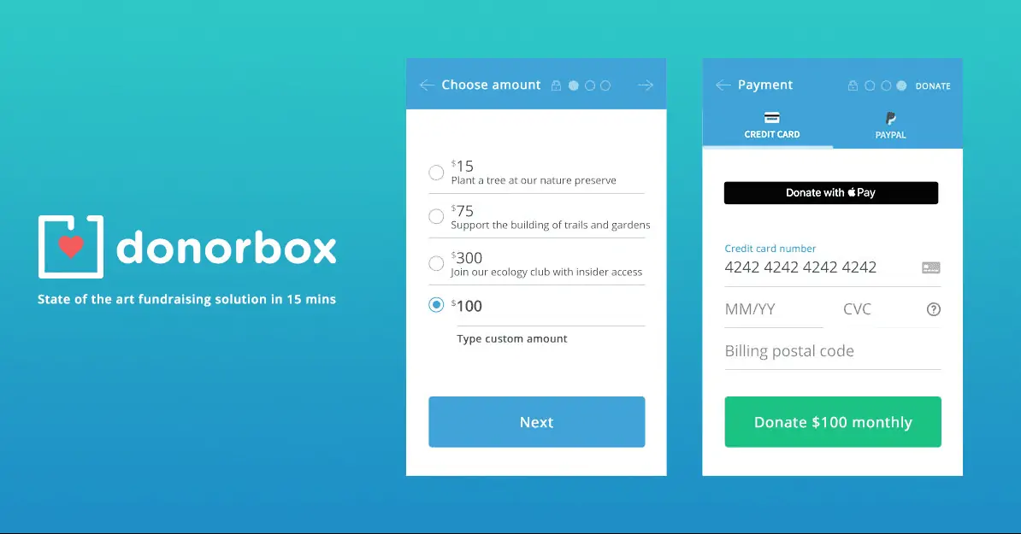
Figure 2.1 DonorBox Payemnt Form

2.4.2. Fundly
Fundly is a great option for individuals looking to raise money for any purpose. Whether or not you're fundraising for a personal cause or for a nonprofit organization, Fundly provides their users with an easy campaign set-up and customer support throughout their campaign. In addition, its pricing is straightforward and competitive when compared to similar websites. (Best Company, 2022)
The ability to keep all donations and funding for your cause is a bonus, relieving the pressure of potentially not meeting your campaign fundraising goal (Donahue, 2023). Instead of worrying about money that could be lost, you will be able to focus on mobilizing more people to donate, helping you reach your overall fundraising goals.
Although Fundly doesn't charge any fees for setting up a campaign or website, it is important to note that a 4.9% and 3% credit card processing fee will be deducted from each donation received. Processing and transaction fees are common in the crowdfunding industry, but rates may vary.
Fundly is a great way to reach those that you already know. It is not recommended for anyone without current support of friends and family through social media, since Fundly's platform functions as a model reliant on the strength of your social media contacts. If you need to solicit donations on a greater scale with a wider audience, there are other crowdfunding sites available that could better fit your needs. (Best Company, 2022)

The platform offers several advantages, including a flexible funding model, no maximum fundraising limit, support specifically designed for nonprofit fundraising campaigns, quick transfer of funds, and step-by-step guidance that makes it easier for users to set up and manage campaigns. However, there are also some gaps to consider, such as the presence of platform fees that may reduce the total funds received and a limited campaign reach, which may make it more challenging to attract a wider audience and maximize fundraising potential

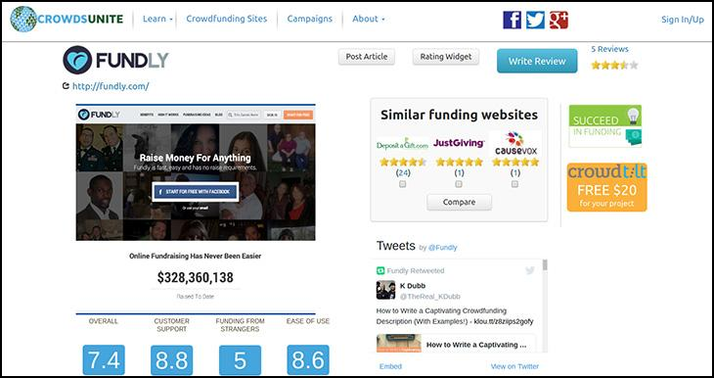

Figure 2.2 Fundly Webpage

Gaps in existing system
The existing systems have certain gaps that need to be addressed. DonorBox, although a comprehensive donation app has limitations. DonorBox provides the best value in the industry as it integrates with other software; it lacks mobile phone integration and collaboration features for effective donor funding among users. Fundly is a fantastic way to reach those that you already know. It is not recommended for anyone without current support of friends and family through social media, since Fundly's platform functions as a model reliant on the strength of your social media. It's important for users to be aware of these limitations and consider alternative tools or approaches to supplement their financial management strategies (Chai, 2023). By addressing these gaps, users can enhance their browsing and donor funding.

Conceptual Framework
The web-based application is a standalone system designed to connect charitable organizations and donors for funding purposes. Charitable organizations can create and upload a portfolio of their past projects, ongoing projects, and project proposals, while donors can check these portfolios and decide whether it is viable for them to donate funds to the organizations. The platform includes administrative functionalities for user management, support, and analytics. It integrates with secure external payment gateways for payment processing, ensures performance optimization, implements security measures, enhances usability, and ensures reliability and accountability. The system is compatible with various web browsers, operating systems, and devices.

The system architecture follows a three-tier model, utilizing technologies such as HTML5, CSS3, JavaScript, React.js, Node.js, Express.js, MySQL, Stripe, PayPal, JWT, and HTTPS. The user interfaces are designed to be intuitive and user-friendly, supporting seamless navigation and accessibility. The system's data flow is illustrated through context level DFD, level 0 DFD, and level 1 DFD diagrams, showcasing processes such as user registration, authentication, deal management, order processing, support, and reporting. The system's test requirements encompass donor, NGO administrator, administrator, and system-level tests, ensuring functionality, usability, integration, and performance are thoroughly validated.
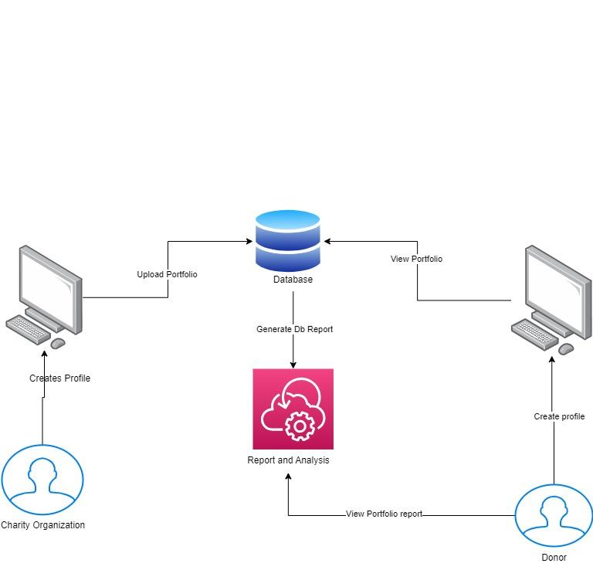
Figure 2.3: Conceptual Framework

Methodology

3.1 Introduction
This project applies an object-oriented analysis and design approach combined with an agile iterative development methodology. OOAD was selected because it supports modular system development through objects, classes, inheritance, and encapsulation, making it suitable for a web-based donor connection system that involves multiple interacting entities such as donors, charities, transactions, and administrators. This approach improves maintainability, scalability, and system clarity.

3.2 Agile Iterative Prototyping Methodology
The project follows an agile-based iterative prototyping methodology consisting of repeated cycles of planning, analysis, design, implementation, testing, and evaluation. Each iteration produces an improved version of the system until the final product meets all requirements. Using an iterative and incremental process, a web-based donor connection system incorporating machine learning was designed, developed, tested, and refined repeatedly until it satisfied all defined requirements. This methodology was chosen because it supports continuous feedback and progressive improvement, making it suitable for developing a system that links Kenyan donors and charitable organizations. Additionally, the prototyping approach allows for the creation of an initial working version that can be evaluated and adjusted or replaced with an improved version if necessary, thereby reducing risk and improving alignment with user and system requirements.

SDM Process Diagram
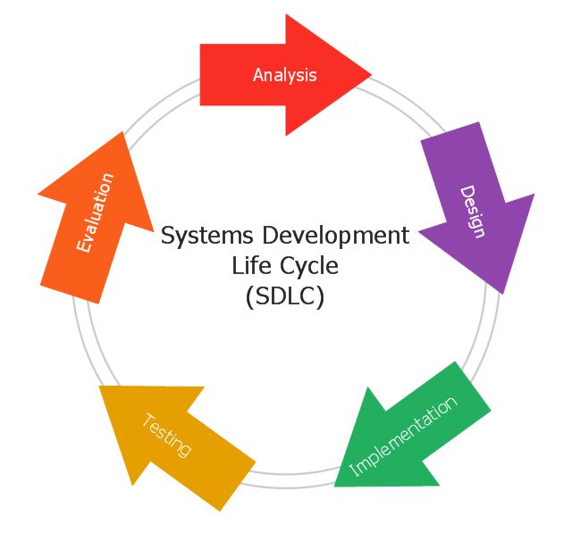

Figure 3.1 System Development Lifecycle

3.2.1 Requirement Gathering
In this phase, data was collected from both NGO employees and donors using structured questionnaires. The purpose was to understand user expectations, challenges in donation systems, and required features such as transaction security, speed, and accessibility. The requirements were then documented to guide system development.

3.2.2 Planning and Analysis
During this stage, the collected requirements were analyzed to define system scope, objectives, and feasibility. Use cases and system requirements were identified, including donor registration, donation processing, charity listing, and reporting. Risks and constraints such as security and transaction reliability were also considered.

3.2.3 System Design (OOAD Phase)
The system was designed using OOAD principles. Key classes identified include User, Donor, Charity, Donation, Transaction, and Admin. Relationships between these objects were modeled to ensure proper interaction. The system architecture was divided into frontend, backend, and database layers to ensure modularity and maintainability.

3.2.4 Implementation, Testing and Refinement
The system was implemented in iterative cycles. Each prototype was developed, tested, and evaluated based on user feedback. Testing included functional testing, security validation, and usability testing. Feedback was used to refine the system until all requirements were met satisfactorily.

3.3 System Implementation Tools
This system links Kenyan donations and charitable organizations via an online application. It is a web-based system that can communicate via the internet to exchange data with an external database. It was chosen because, with an internet connection, it is accessible from anywhere. The development process was carried out in three stages: database, front-end, and back end.

3.3.1 Front End
The user interface of the web application that links Kenyan contributors and charitable organizations was the primary focus of the front-end development. It was made up of the graphical user interfaces that users would utilize to communicate.
CSS and HTML were utilized for the front-end. The Cascading Style Sheet, or CSS, was added to the system to improve its appearance and user-friendliness for the client. The system was styled with it. The standard markup language for pages intended to be viewed in a browser was HTML, or HyperText Markup Language. It provided a general overview of the system's design. Visual Studio Code was chosen to build the system because it is an easy-to-use IDE with excellent support for debugging and developing useful extensions. Visual Studio Code distinguishes the different file formats, such as PHP, HTML, CSS, and JS files.

3.3.2 Back End
The creation of all the work that goes on behind the scenes of the web application that links Kenyan donors and charitable organizations is known as back-end development; this is the portion that the user does not see. It was applied to develop the functionality and structure of the system. The application, server, and database make up the back end.
JavaScript and PHP were used on the back end. The system was made interactive by utilizing JavaScript. It made it possible for the system to react to different inputs and communicate with a variety of users, clients, staff administrators, and management. It kept the web-based program from becoming a static system, which links Kenyan charitable organizations with funders.
PHP was used to connect securely to the database located on the PhpMyAdmin local server and connect the different modules with the donor’s module.

3.3.3 Database
For record-keeping and security reasons, a database including a variety of donor, staff-admin, and system data from multiple modules is kept by the web-based program that links Kenyan charitable organizations with contributors. A relational database management system called MySQL was employed for the database. MySQL allows for transactions and is quite secure.

3.3.4 Testing
Following the creation of a web-based program, which links Kenyan contributors with charitable organizations, the system was tested to ensure it was constructed correctly. Testing was essential since it revealed mistakes and malfunctions, which increased trust in the system's general dependability. There were many other kinds of tests conducted, such as black box testing.These tools were selected for their compatibility with OOAD design principles, scalability, and ease of integration for web-based applications.
Component | Tool/Technology Used
Frontend | HTML, CSS, JavaScript
Backend | Python (Django / Flask)
Database | MySQL / SQLite
IDE | Visual Studio Code
Version Control | Git & GitHub
Machine Learning | Python (Scikit-learn / Pandas)
API Integration | REST APIs

Table 2: Tools used for implementation

3.4 Deliverables
The project deliverables are structured into system modules that represent functional components of the donor connection system.

3.4.1 User Authentication Module
This module handles user registration, login, password management, and role-based access control for donors, charities, and administrators.

3.4.2 Donor Management Module
This module allows donors to create profiles, view charities, and manage their donation history.

3.4.3 Donation Processing Module
This module manages the donation workflow, including selecting charities, processing transactions, and generating receipts.

3.4.4 Reporting and Analytics Module
This module provides system reports, donation analytics, and insights using machine learning to identify donation trends and user behavior.

Chapter 4: Analysis and Design

4.1 Introduction
The processes that aid in converting requirement specifications into implementation are analysis and design. There has been a clear statement of both the functional and non-functional needs. Specified tasks by specified job holders and what each user is expected to accomplish within the system make up the functional requirements. The system and its characteristics are covered in greater detail under the non-functional criteria. The use case diagram, sequence diagram, class diagram, system architecture, database schema, and ERD were among the six diagrams that were created.

4.2 Requirements Analysis

4.2.1 Functional Requirements
A specific task carried out by a certain task holder makes up the functional requirements. They clarify what the system is supposed to do for each user. In this system, there were three users: donor, staff admin, and management. Each of the three consumers has unique needs in terms of functionality.
Donor Functional Requirements
(i) The system should allow the donors to log in.
(ii) The system should allow a donor to register as a new donor.
(iii) The donors should be able to enter their details.
(iv) The donors should be able to view their entered details.
(v) The system should display the status to the donor that is pending, accepted, or rejected.
(vi) The system should allow the donors to assess their worthiness.

Staff Functional Requirements
(i) The system should allow the staff to login into the system.
(i) The system should allow staff to register a new donor.
(ii) The system should enable staff to view donors' details.
(iii) The system should enable staff to edit a donor’s details.
(iv) Staff should be able to view their own details.
(v) The system should allow the admin staff to register other staff.
(vi) The system should allow the admin staff to assess the portfolio of a donor.
(vii) The staff should be able to reject and accept portfolio applications.
Manager Functional Requirements
(i) The system should allow a manager to log in.
(ii) The system should allow managers to approve new staff.
(iii) The manager should be able to view the general reports.

4.2.2 Non-Functional Requirements
The non-functional requirements are the requirements that talk more about the system and its features; that is, how good is the system.
The non-functional requirements include:
(i) Secure file transfer: No information is leaked by the system, which is secure.
(ii) Usability: It's simple to use and comprehend the system.
(iii) Reaction time: The system reacts to human input very quickly.
(iv) Load time: Both inputs and outputs from the system happen quickly.
(v) Privacy: Each user's account is kept private by the system, and no user can access another user's.

4.4 Diagrams

4.4.1 Use Case
The use case diagram depicts the different users or actors in the system. Four actors make up this system: manager, staff, admin, and donors. Every actor has unique functional needs. The inability of one actor to switch to another actor's module indicates the boundaries of the system.

4.4.1.1 Use CaseNarrative
Use Case | Registering into the system
Actors | Donor
Goal | The goal is to register successfully into the system
Pre-Condition | The user does not have an account in the system.
Post-Condition | The user has an account in the system and can login with their credentials
Narrative | The user will first access the system which is available over a network and proceed to the Homepage of the system and before proceeding they will be requested to either login in or register
Alternate condition | The user can not make any changes into the system unless they are registered and logged in.

4.4.1.2 Use CaseNarrative
Use Case | Login into the system
Actors | Donor & Staff Admin
Goal | The goal is to log in successfully into the system
Pre-Condition | The user has an account in the system
Post-Condition | The user is taken to their respective module
Narrative | The user will navigate the system and click the login button and be taken to their respective module depending on the type of user
Alternate condition | If the password or username is invalid, the system will deny entry.

4.4.1.3 Use CaseNarrative
Use Case | Enter Application Details into the system
Actors | Donor & Staff-admin
Goal | The goal is to successfully enter a charity organisation’s portfolio application details into the system
Pre-Condition | The user has an account in the system
Post-Condition | The user is taken to their respective portfolio application module
Narrative | The user will navigate the system and click the login button and be taken to their respective module depending on the type of user, they will then navigate to the portfolio application module and enter their details to apply for donation.
Alternate condition | If the details are not completely filled, the system will not allow them to continue

Table 3: Use Case Diagram

4.4.2 Sequence Diagram
Client Sequence diagram
The sequence diagram for the donor shows all the activities that are done by the donor and the order in which they are carried out. The donor logs in, registers and enters data, then views the portfolios. The details of the client are then stored in the database. The diagram also incorporates the shows all the activities that are done by the staff and in the order they follow. The staff logs in, retrieves the donor’s details to view the different donors available . It also shows all the activities that are done by the manager in order they follow each other. The manager logs in, receives staff details and reports. The manager now approves new staff.
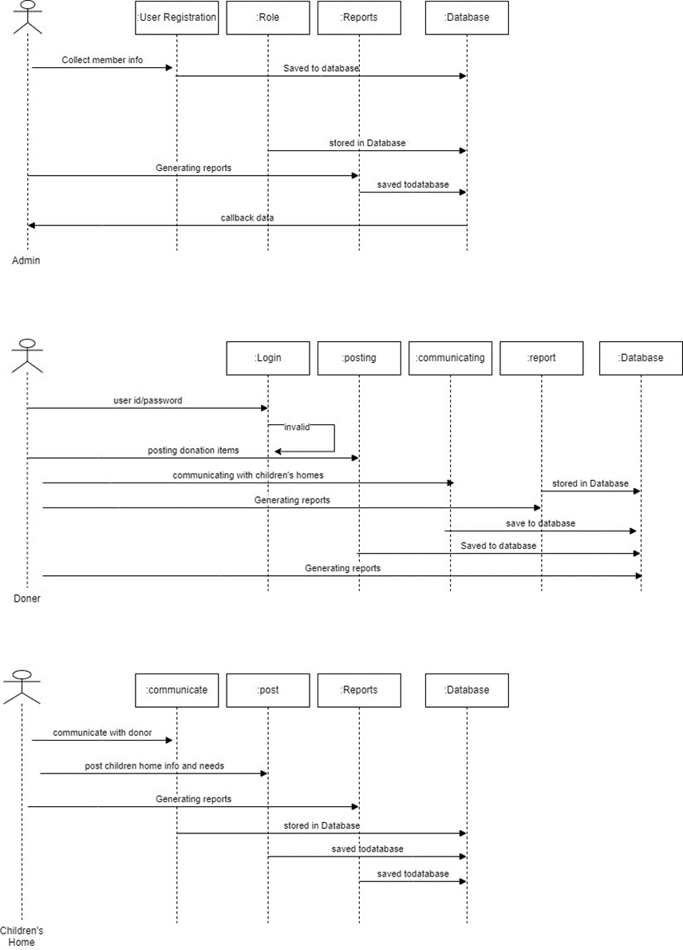

Figure 4: Sequence Diagram
4.4.3 Database Schema
The database schema shows all the tables in the database and their respective entities. Each table has a primary key denoted by the PK. The primary is unique and cannot be repeated throughout. There are also foreign keys in some tables denoted by FK. The foreign key is a key that is primary key in another table but now has appeared in another table but as not as primary key. This creates relationships between the tables. The schema also shows the length of each entity and the datatype that has been used.
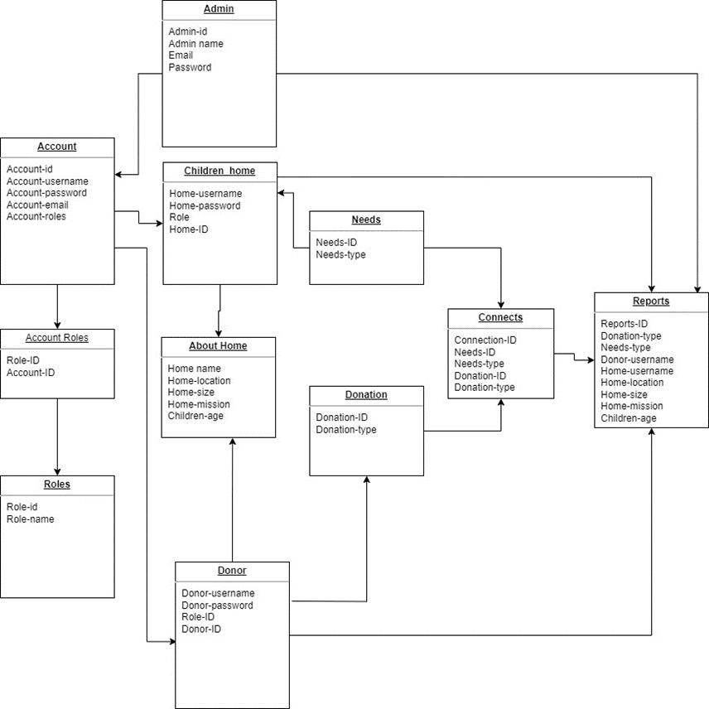
Figure 5: Database Schema

TABLE | FIELD | TYPE
Donor Table | DonorID | Int
 | Name | Text
 | Email | Text
 | Phone | Int
 | Role | Enum
 | Password | Text
 | Image | Text
Charitable Org | OrgID | Int
 | Name | Text
 | Phone | Int
 | Email | Text
 | Address | Text
 | Mission | Text
 | Location | Text
Project Table | ProjectID | Int
 | Name | Text
 | OrgID **fk | Int
 | Description | Text
 | Goal | Text
 | Current funds | Int
 | Start date | Date
 | End date | Date
Portfolio Table | PortfolioID | Int
 | DonorID **fk | Int
 | Name | name
 | Total Funds | Int
 | Status | Enum
Portfolio Projects | Portfolio Project ID | Int
 | PortfolioID **fk | Int
 | ProjectID **fk | Int
 | Donation Amount | Int
 | Donation Date | Date
Transaction Table | TransactionID | Int
 | DonorID **fk | Int
 | OrgID **fk | Int
 | Amount | Int
 | Transaction Date | Date
 | Transaction Type | Text

4.4.5 Class Diagram
The class diagram shows the methods and variables for the objects. It also shows the parent classes. In this diagram the arrow points to the parent class while the arrow originates from the child class. Classes that point another class with diamond sign means that they fully depend on them . It cannot exist without the other.
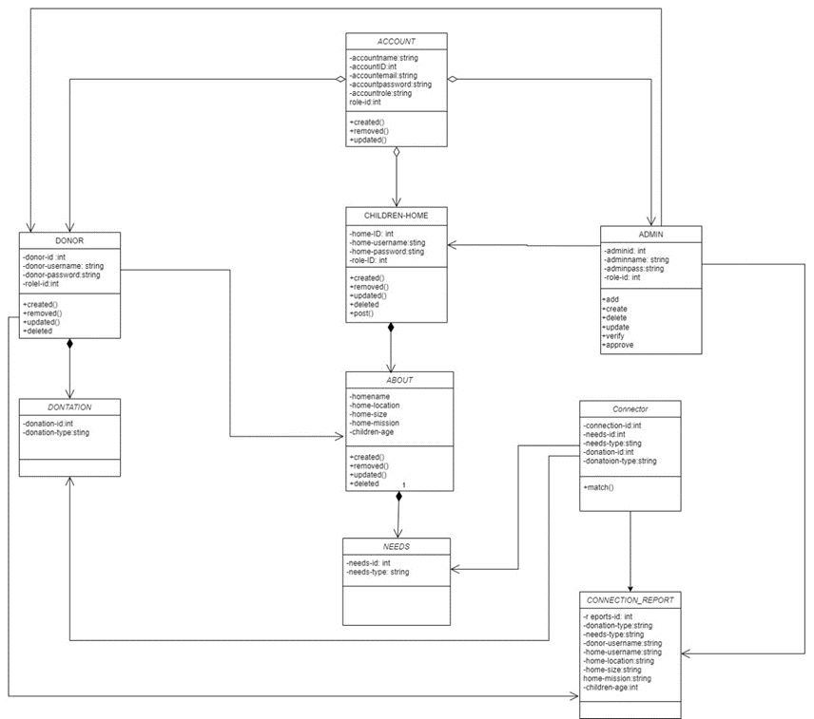
Figure 5: Class Diagram

Chapter 5: Implementation and Testing

5.1 Introduction
This chapter presents the implementation and testing of the web-based application designed to connect charity organizations to donors in Kenya. It covers the key modules developed, the tools and technologies employed during implementation, and the sample source code illustrating critical system functions. Furthermore, the chapter details the testing strategy adopted, the test cases executed, and the results obtained to validate the system's functionality, performance, and reliability.
The implementation followed an agile iterative prototyping approach, allowing continuous testing and refinement throughout the development lifecycle. The final system integrates a front-end built with HTML, CSS, and JavaScript; a back-end developed using PHP; and a relational database powered by MySQL all developed within the Visual Studio Code integrated development environment

5.2 Description of the Implementation Environment
The system was developed in modular phases, with each module independently implemented and tested before integration. The implementation addressed three core architectural layers: the front-end user interface, the back-end application logic, and the database layer. The following sub-sections detail the implementation of the primary system modules

5.2.1 Hardware Specifications
The system's functioning was not compromised in order to accommodate a large number of users. An overview of the suggested hardware requirements to run the system can be seen below.

Component | Specification | Description
Processor | Intel Core i5 or equivalent | Provides sufficient processing power for client-side tasks.
RAM | 8 GB | Ensures smooth performance when running the web application.
Storage | 256 GB SSD | Fast storage for quick data access and application loading.
Graphics Card | Integrated graphics or equivalent | Adequate for web-based applications.
Network Connectivity | Ethernet/Wi-Fi | Ensures internet connectivity for accessing the web app.
Display | Full HD (1920x1080) | Provides a clear and crisp display for users.
Table 4: Hardware Specifications

5.2.2 Software Specifications
The following software is needed for the system to fully function:

5.2.2.1. Operating System
Due to its stability and strong Microsoft distribution support, the system was designed and tested under Windows 10 version 22H2.

5.2.2.2 Web Server
The system was hosted via the XAMPP web server on a local Apache 2.4.54 HTTP server. The server was compatible with earlier server versions, including Apache 2.4.46, and handled HTTP requests and static content with efficiency.

5.2.2.3 Database Management System
Due of its robustness and open-source nature, the constructed system used the MYSQL relational database management system version 15.1 during production.

5.2.2.4 Browser
The most recent Chrome browser version (119.0.6045.199) was used to test the web application to make sure it was compatible with the cutting-edge web technologies.

5.3 Description of Testing
The testing process encompassed four levels of validation: functional testing to verify that each feature performed its intended operation; security testing to assess the robustness of the authentication and payment modules against common vulnerabilities such as SQL injection and cross-site scripting (XSS); usability testing conducted with a sample group of five donors and two NGO administrators to evaluate the intuitiveness of the user interface; and performance testing to assess system responsiveness under simulated concurrent user loads.
All identified defects were logged, categorized by severity, and resolved before the final system version was produced. The following sections present the structured test cases and their corresponding results.

5.3.1 Evaluations and Metrics Used
Ensuring the quality and appropriateness of the data for the task required meticulous preparation. This required cleansing the data and checking it for mistakes, inconsistencies, and missing numbers.
Errors were fixed, and missing values were removed or appropriately handled by imputation. Additionally, data normalization was done to make sure that all of the characteristics had the same scale.
To gauge the models' performance on unobserved data, they were tested using the testing set. The models were assessed using the following metrics: recall, which measures the percentage of true positives that are correctly detected, accuracy, which measures the percentage of correct predictions made by the model, and precision, which measures the percentage of positive predictions that are genuinely correct. To make sure that the model's performance is consistent across several data subsets, cross-validation was also carried out.

5.3.2 Testing Paradigm (Functional Testing)
Black-box testing was used to carry out Functional testing which was typically conducted from an external perspective, where the tester did not have knowledge of the internal code or logic. It tested the software application by testing its individual functions or features.
The following were the testing results for the different functional requirements:

Table 5.2: Test Case 1
Functional  Requirement | Test Data | Expected Result | Actual  Result | Verdict  (Pass/Fail) | Evidence
Allow users to register/login to system (eg. register donor) | FirstName: Emily  LastName: Miker  Password: Emily  Phone Number:0710702411  Address: Nakuru  Support: shoes and clothes  Description:3 pairs of Nike shoes  Status: current donation  Emainl:Emily@gmail.com | Redirect user to “Success page” | Donor was directed to “Success page” | Pass | Screenshot of Success page  (See appendix 6 Figure 5.1)

Table 5.3: Test Case 2
Functional  Requirement | Test Data | Expected Result | Actual  Result | Verdict  (Pass/Fail) | Evidence
Allow children’s home to post their information and make donation request | Home name: The King of Hearts  Address: Gambia  Contact person: Guya  Email:Haven@gmail.com  Password: Haven  Phone Number:0723239587  Description: Serene and tranquil, The Haven at Willow Creek off...  food  Link:www.Haven.com | Data is stored and reflected on Viewhomes page | Data can be viewed on Viewhomes page | Pass | Screenshot of “Viewhome”page  (See appendix 6 Figure 5.2 and 5.3)

Table 5.4: Test Case 3
Functional  Requirement | Test Data | Expected Result | Actual  Result | Verdict  (Pass/Fail) | Evidence
Allow donors to view children home information | - | Display “Viewhomes” page | “Viewhomes” page is displayed | Pass | Screenshot of “Viewhomes page” (See appendix 6 Figure 5.4)

Table 5.5: Test Case 4
Functional  Requirement | Test Data | Expected Result | Actual  Result | Verdict  (Pass/Fail) | Evidence
Allow donors to post donation information | Support: clothes  Description: Lab coats for science students  FirstName: Bob  Phone Number: 0755667788  Status: Current donation | Data reflects on donation board | Data is seen on donation board | Pass | Screenshot of donation board (See appendix 6 Figure 5.5 and 5.6)

Table 5.6: Test Case 5
Functional  Requirement | Test Data | Expected Result | Actual  Result | Verdict  (Pass/Fail) | Evidence
Allow admin to manage accounts.  (eg. Delete a donor account) | FirstName: David | System should remove the donor from the donor section | The account was removed | Pass | Screenshot of Deletion page  (See appendix 6 Figure 5.7)

Test Case 1
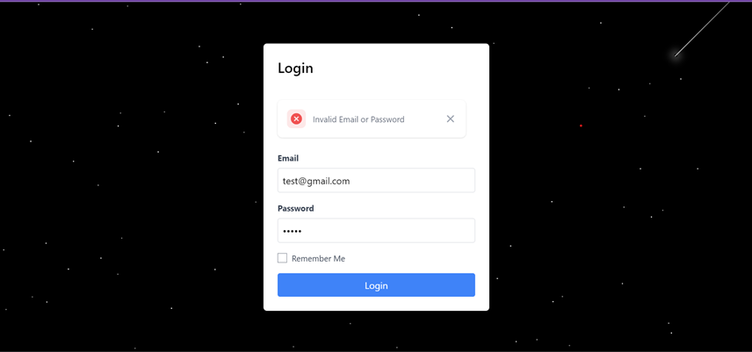

Test case 2
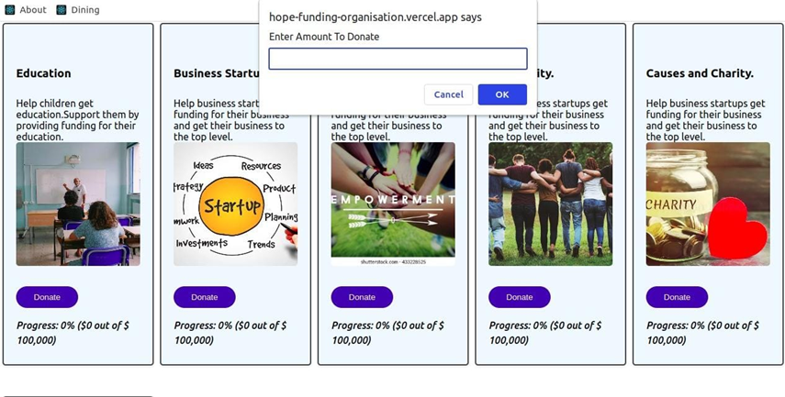

Test Case 3
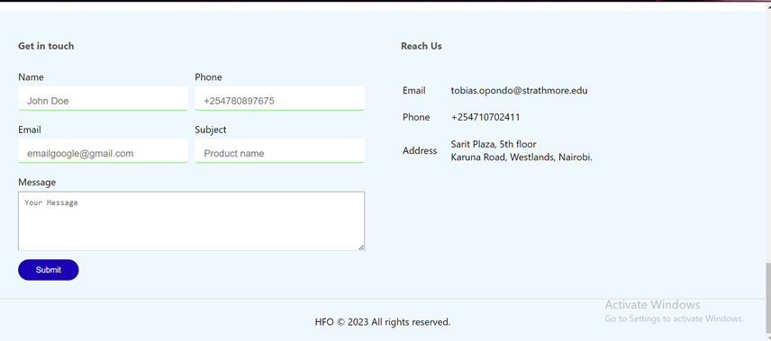

Chapter 6. Conclusion and Recommendation

6.1 Conclusion
This project is built on connecting donors to charity organizations, where an admin in a charity organization logs in with the goal of getting connected to a donor for financial aid and project support. The donor and admin modules are the two distinct functional modules of the system. To effectively illustrate the functional requirements, seven diagrams were created, including a use case diagram, sequence diagram, database structure, class diagram. Multiple computer languages, including PHP, MySQL, HTML, CSS, and JavaScript, were used in the development of the system. Various tests, including user acceptability, unit, integration, and thread tests, were conducted on the system .All the two modules work together to achieve one main goal which is the connection to the donor. The admin applies for a connection which can either be financial aid or project support. The donor analyzes the details of the organization from the portfolio and makes a decision to support the charity organization or not.
Charity organisation no longer need to write several e-mails convincing the donors on why they should help them fund their projects and charity works making it much easier and faster. This project has brought into light the issues that arise from fundraising events that might be deemed to be corrupt.This system hence solves the long durations of time charity organisations waste while waiting to connect with donors around the globe. The system has also been tested ensuring there are no gaps and errors.
This system has both functional and non-functional requirements for the three modules, starting with the client’s module the following are the functional requirements that were able to be achieved:
(i) The system allows donors to login.
(ii) The system allows donors to register.
(iii) The system allows donors to enter their details.
(iv) The system allows donors to view their entered details.
(v) The system allows donors to assess their worthiness.
There is no functional requirement in the client module that has not been achieved; all the functional requirements were achieved successfully.For the admin the following functional requirements were achieved:
(i) The system allows the admin to login.
(ii) The system allows the admin to register new staff.
(iii) The system allows admin to view donors details.
(iv) The system allows admin to register other admins.
All the functional requirements of the admin were met.

References
Adapt, C. (2017, May 02). Identifying indicators for monitoring and evaluation. Retrieved from Identifying indicators for monitoring and evaluation: https://coastadapt.com.au/how-to-pages/identifying-indicators-monitoring-and-evaluation
Ajay Raut, P. S. ( 2023, May). Fundraising Tracking System for NGOs Using Blockchain. Retrieved from ResearchGate: https://www.researchgate.net/publication/371170955_Fundraising_Tracking_System_for_NGOs_Using_Blockchain
Angelsen, A. (2014, March 14). Forest News. Retrieved from Ten challenges and lessons for donors funding REDD+ as performance based aid: https://forestsnews.cifor.org/21740/polex-ten-challenges-and-lessons-for-donors-funding-redd-as-performance-based-aid?fnl=en
Ashley, S. (2019, December 3). Non profit Quaterly. Retrieved from Why the Decline in Individual Donors Should Matter to Institutional Philanthropy—and What to Do about It: https://nonprofitquarterly.org/why-the-decline-in-individual-donors-should-matter-to-institutional-philanthropy/
Asianngo. (2023, October 18). asianngo. Retrieved from 15 Sources of Funding Sources for Non-Profit Organizations: https://asianngo.org/magazine/post-magazine/article/article-detail/90/15-sources-of-funding-sources-for-non-profit-organizations
Assefa, B. (2023, Nov 4). Learning and development! Retrieved from UNICEF: https://www.unicef.org/ethiopia/learning-and-development
Attridge, H. W. (2020). Yale University. Retrieved from Early Christians and the Care of the Poor: https://reflections.yale.edu/article/no-more-excuses-confronting-poverty/early-christians-and-care-poor
B, V. (2018). Adam — latest trends in deep learning optimization. Towards Data Science, 1-2.
Baranowski, R. (2019, May 22). Internationl Republican Institute. Retrieved from Strengthening Accountability through Decentralization in Kenya: https://www.iri.org/news/strengthening-accountability-through-decentralization-in-kenya/
Barlett, A. (2016). Evaluating relative success of donor-funded collaborative research projects. Evaluating relative success of donor-funded collaborative research projects.
Best Company. (2022, December 6). Best Company. Retrieved from Fundly: https://bestcompany.com/crowd-funding/company/fundly
Casucian, I. (2023, June 3). Technology Advice. Retrieved from What is Agile Project Management (APM)?: https://technologyadvice.com/blog/information-technology/what-is-agile-project-management/
Chai, W. (2023, December 13). Tech Target. Retrieved from CRM (customer relationship management): https://www.techtarget.com/searchcustomerexperience/definition/CRM-customer-relationship-management
Chiesa, C. (2023). The contribution of crowdfunding for philanthropy: A systematic review and framework of donation and reward crowdfunding. Journal of Philanthrophy and Marleting.
Deepchecks. (2023, November 16). Deepchecks glossary. Retrieved from Deepchecks website: https://deepchecks.com/glossary/rectified-linear-unit-relu/#:~:text=ReLU%20formula%20is%20%3A%20f(x,range%20of%200%20to%20infinite.
Donahue, M. (2023, January 2). Donor Management: A Guide To Effectively Managing Your Nonprofit’s Donors. Retrieved from Donor Management: A Guide To Effectively Managing Your Nonprofit’s Donors: https://www.causevox.com/blog/donor-management/
Duong, M. (2020, March 2). The Challenges of Developing a Budget during Strained Times. Retrieved from The Challenges of Developing a Budget during Strained Times: https://er.educause.edu/blogs/2020/3/the-challenges-of-developing-a-budget-during-strained-times
Fernando, J. (2023, April 23). Corporate Social Responsibility (CSR) Explained With Examples. Retrieved from Corporate Social Responsibility (CSR) Explained With Examples: https://www.investopedia.com/terms/c/corp-social-responsibility.asp
Friedenthal, A. (2018, April 4). Software Advice. Retrieved from Combat These 5 Major Causes of Donor Fatigue: https://www.softwareadvice.com/resources/causes-of-donor-fatigue/
Goodbudget. (2023, n.d n.d). How it works. Retrieved from Goodbudget: https://goodbudget.com/how-it-works/
Jacinta, D. P. ( 2022). Effect of Funding Diversification on the FinancialPerformance of Nongovernmental Organizations in Kenya: ACase of Kenya Red Cross Society. European Scientific Journal, 78.
Jensen, J. (2023). 2023 Donorbox Review – . The Best Recurring Donation App for Squarespace and Wix? Retrieved from The Digital Nonprofit: https://thedigitalnonprofit.com/donorbox-review/#:~:text=Donorbox%20is%20cheap%2C%20effective%2C%20has,will%20instantly%20boost%20your%20fundraising.
Kenton, W. (2023, March 4). Nonprofit Organization (NPO). Retrieved from Nonprofit Organization (NPO): https://www.investopedia.com/terms/n/non-profitorganization.asp#:~:text=Nonprofits%20often%20rely%20on%20individual%20donors%20who%20contribute,channels%2C%20including%20online%20platforms%2C%20direct%20mail%2C%20or%20events.
Kihlstedt, A. (2022, March 2). Capital campaigns and donor fatigue: combatting your fears. Retrieved from Candid: https://blog.candid.org/post/capital-campaigns-and-donor-fatigue-combatting-your-fears/
Koehler, J. (2019, May17). A Guide to Organizational Resources and How to Manage Them. Retrieved from University of Arkansas Grantham: https://www.uagrantham.edu/blog/a-guide-to-organizational-resources-and-how-to-manage-them/
Lutkevich, B. (2023, May 29). SSADM (Structured Systems Analysis and Design Method). Retrieved from SSADM (Structured Systems Analysis and Design Method): https://www.techtarget.com/searchsoftwarequality/definition/SSADM

